Exp. 1 Design an LED ﬂasher

**Aim** Design a LED flasher.

**Apparatus**: Arduino Board, LED.

Theory: LED Flasher are semiconductor integrated circuits used to turn on and off groups of light emitting diodes either sequentially or according to a programmed pattern. They are found in circuits used as indicators and controllers, as well as in home-built.

Circuit Diagram:

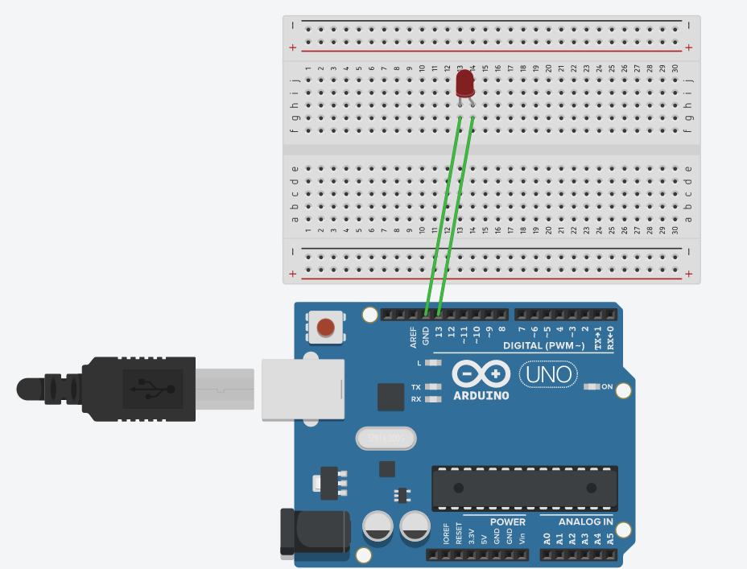 Observation : 1. Observed Blinking of LED.

2. Working of Arduino.

3. Different sections of Arduino.

4. Coding for Arduino to blink a LED.

Precautions: 1. There should not be any loose connection in the circuit.

2. Code should be written properly.

3. Arduino should be attached to pc/laptop properly.

Code:

void setup()

{

pinMode(13 , OUTPUT);

}

void loop()

{

digitalWrite(13 , HIGH);

delay(1000);

digitalWrite(13 , LOW);

delay(1000);

}

Result : Blinking of LED was verified after uploading the program.